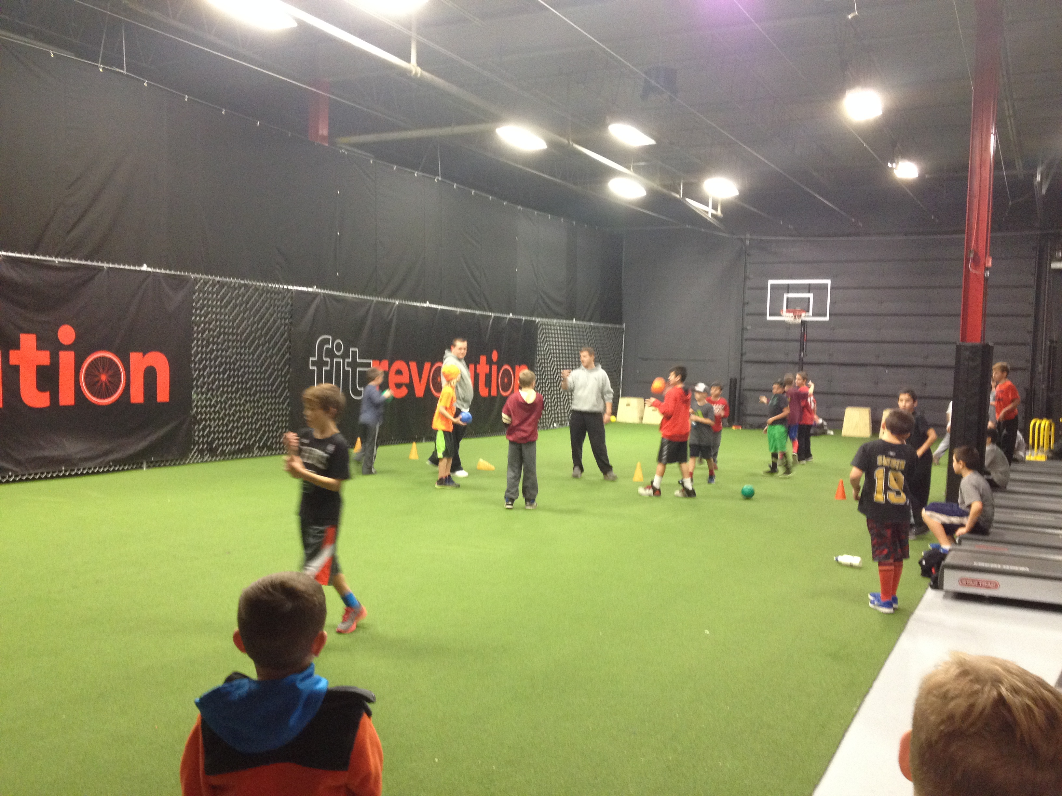

Sports Zone 101 at Fit Revolution

North Reading, MA 2015

FRIDAYS: 3:30 to 5:00pm SATURDAYS: 10:30-12:00pm Register at www.fit-rev.com

STARTING JANUARY 23rd and January 24th

## Join the Sports Zone 101 Team at Fit Revolution to participate, drop-in, and play with this action packed program all winter long. All kids will participate in a variety of games, such as street hockey, soccer, football, dodgeball, basketball and many others. Each participant will receive a sports prize of the day. Come learn about our REWARDS SYSTEM for a chance for to win tickets to the Bruins, Celtics, Red Sox, or other game. PROGRAMS OPEN TO ALL!!!!

## Contact info@sportszone101.com for more details about our programs at Fit Rev.

# Tournament of Champions Returns to Fit Rev

23 Concord Street, North Reading, MA