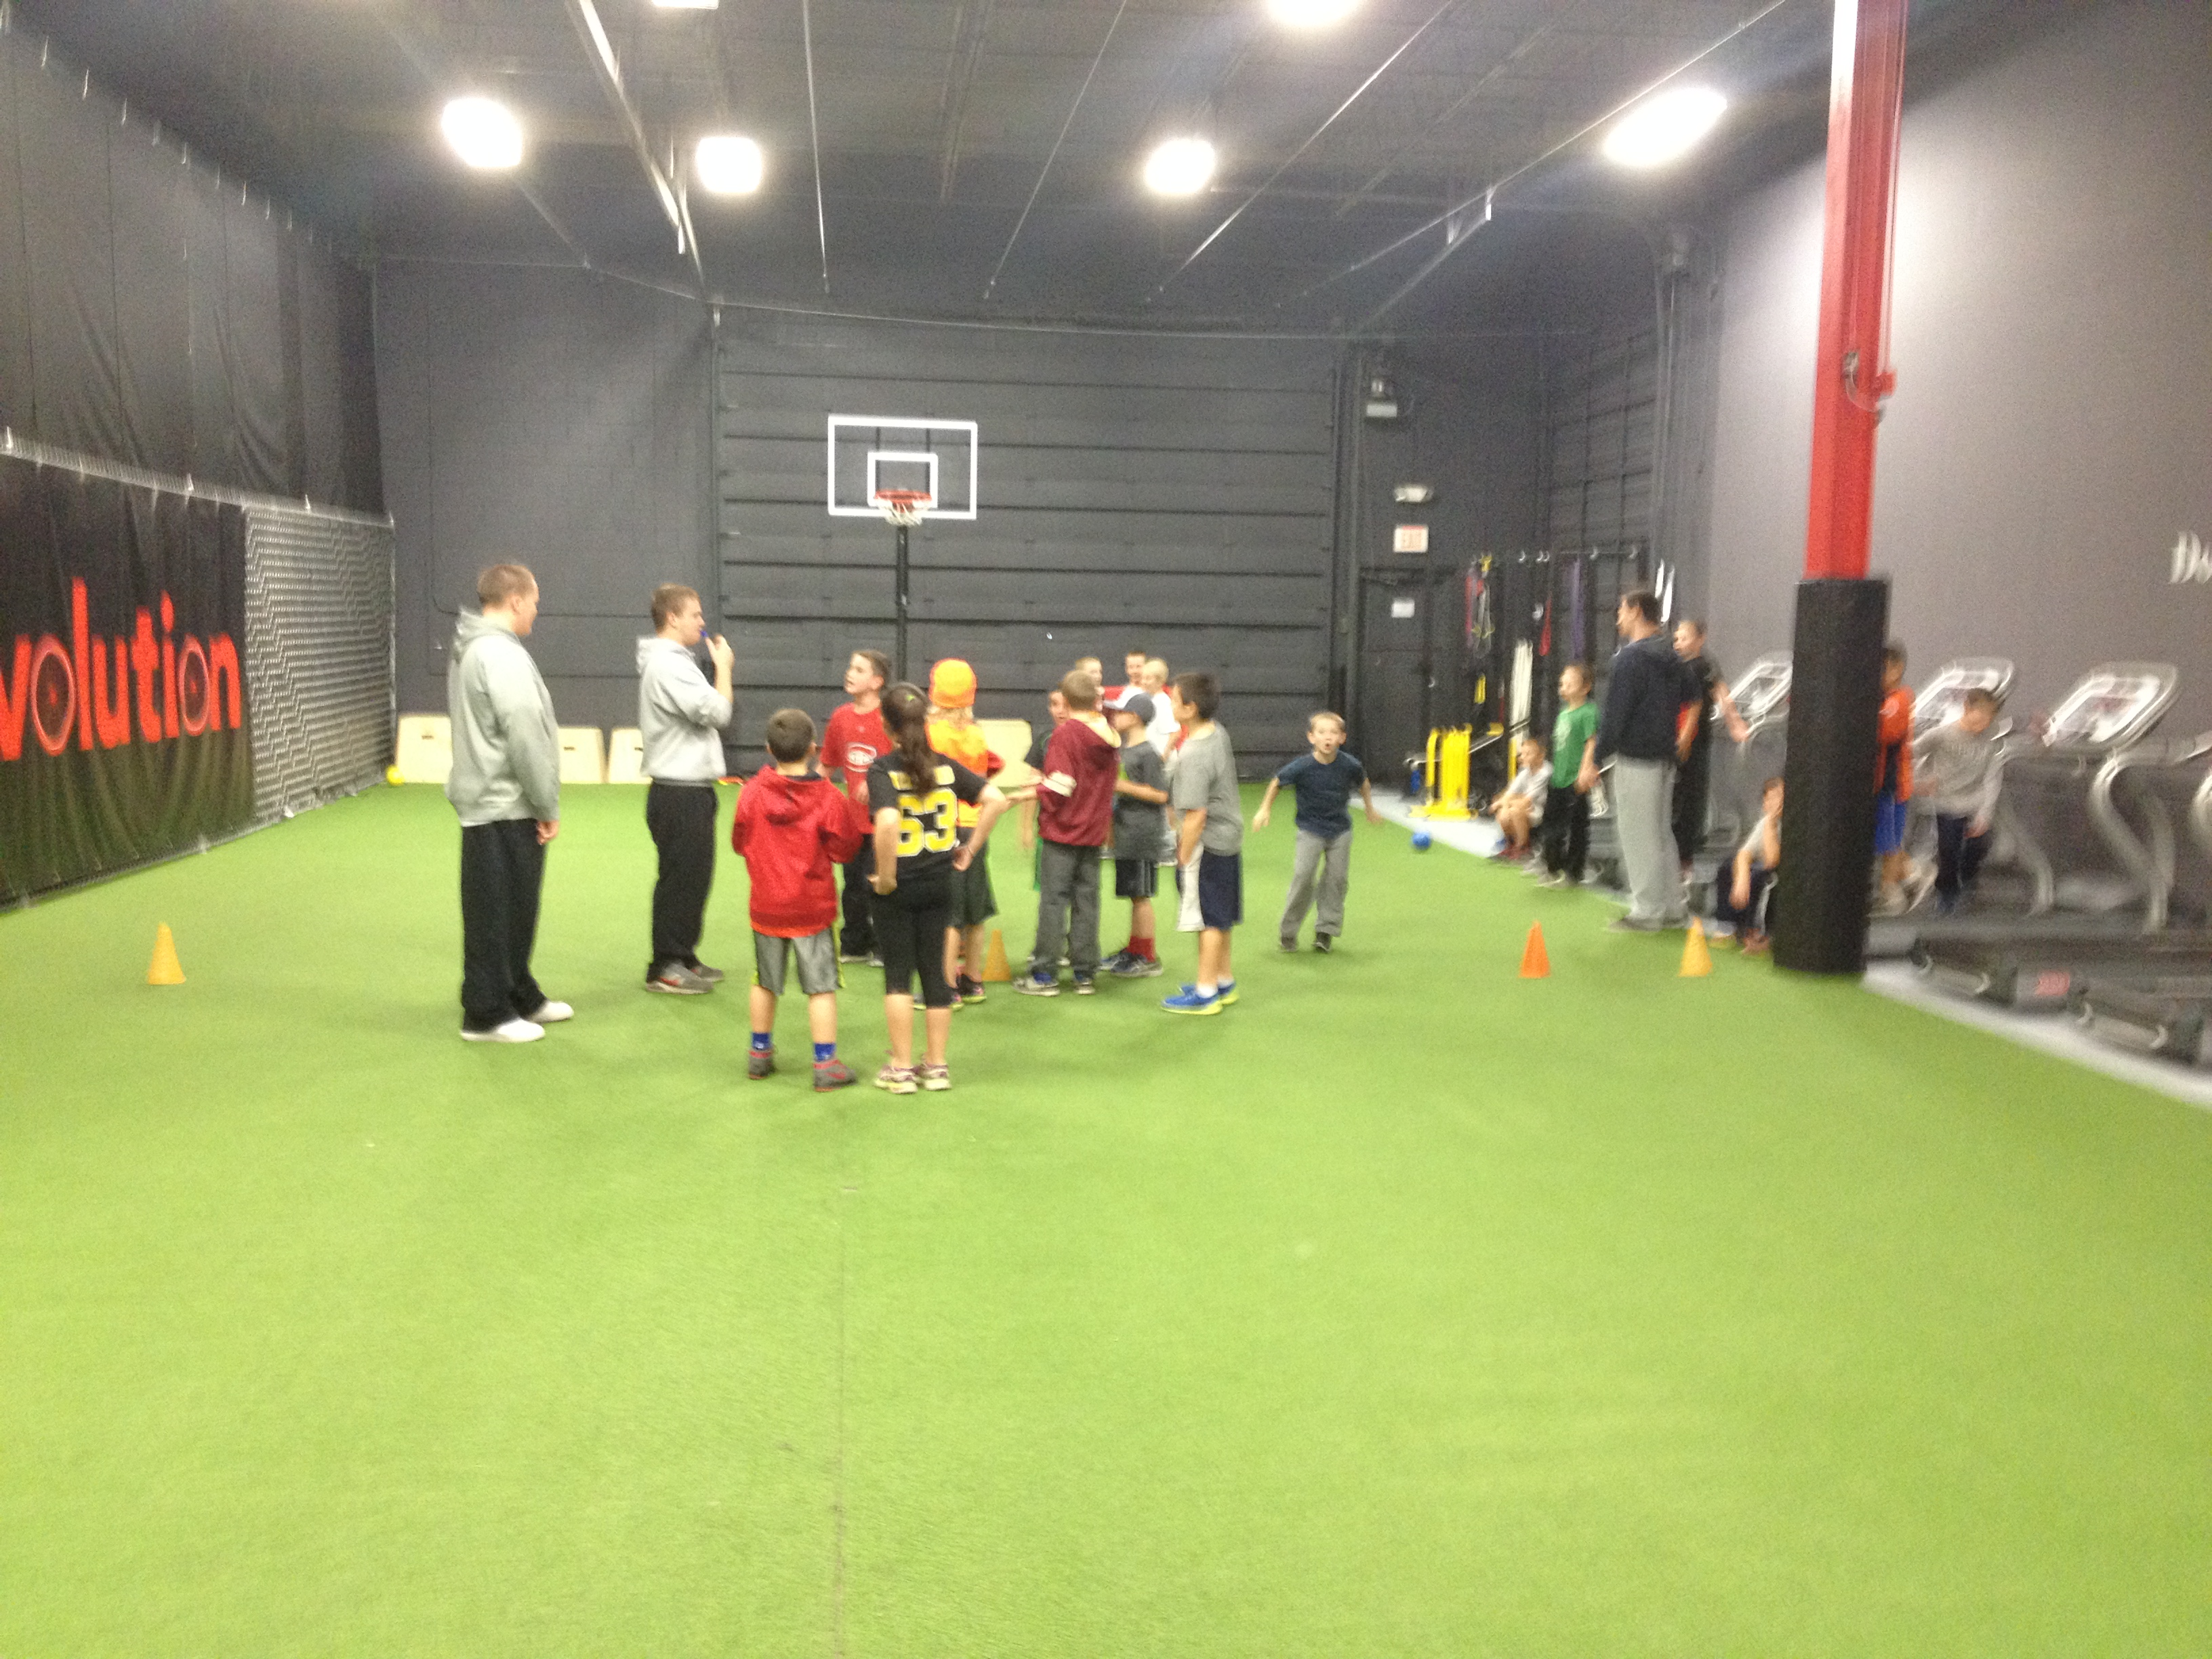

SPORTS AT FIT REV

## Join the Sports Zone 101 Team for a fun night with your friends!!!

## Parents can enjoy a great night out while your kids participate in some great fun with our wonderful team of coaches, leaders, and role models!

## **ENTERTAINMENT INCLUDES:**

## MUSIC, EXERCISE, GAMES, FOOD, DRINK, PRIZES, and MORE

## **ADMISSION: $30 INCLUDES FOOD, DRINK, and PRIZE!**

## Contact info@sportszone101.com for more details about our programs at Fit Revolution

# “Sports Night” Friday Nights at Fit Rev

# with Sports Zone 101

FRIDAYS: 6:00pm to 9:00pm – register at

[www.fit-rev.com](http://www.fit-rev.com)

STARTING JANUARY 23rd

23 Concord Street, North Reading, MA