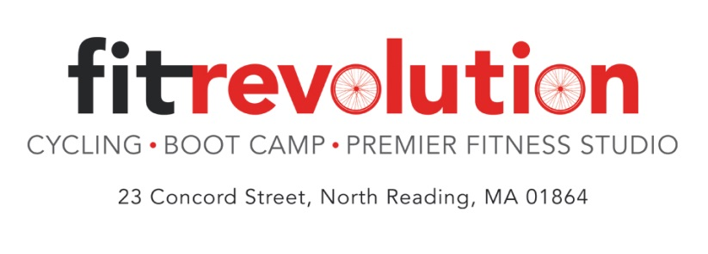
BY POPULAR DEMAND…..
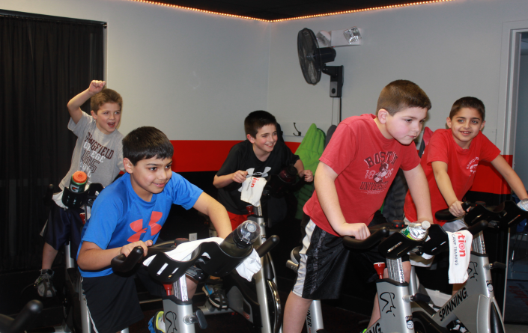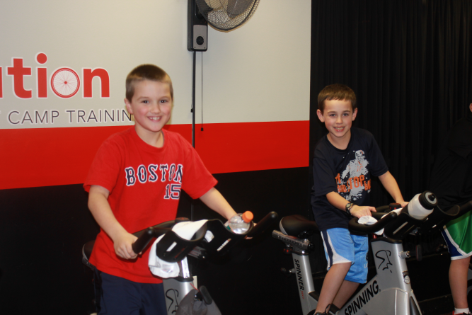
Kids Spin starting the week of October 20th
Tuesdays or Thursdays 4:00 – 4:45

Spinning is a safe, healthy and low-impact form of exercise for kids. It's easy to learn, suitable for all body types and fitness levels, and allows a group to exercise safely in one easy-to-monitor location.
- Kids must be at least 50 inches tall to participate
- Pre-registration required
- Cost is $90 for a 6 week session (meets 1x a week)
- Registration is on a first come basis.
Fit Revolution is proud to offer this new class to get kids excited about fitness and help start the development of lifelong healthy habits.

To register go to www.fit-rev.com and click on “sign up for a class”, each participant should create an account and sign up under Events.

