**Fit Revolution is excited to announce….**

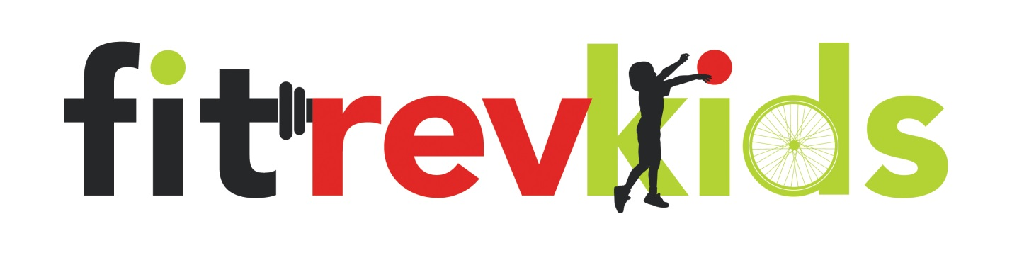

**This fall we will be having classes for Kids after school so you can ensure they are staying healthy and ACTIVE!**

**Just leave it to us… Drop them off for 1 hour and we will take care of the rest!**

**All Kids are welcome and the best way to get your child going is to find a friend to bring with them…**

**Starts week of September 8th**

**Cost - $90 per session – 6 classes**

**Pick your class –**

**SPINNING**

**BOOT CAMP**

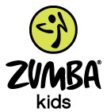

**TRAIN TO RUN CAMP**

**SPORTS CONDITIONING**

**Sign up today by going to** [**www.fit-rev.com**](http://www.fit-rev.com) **and click on Sign up for a class. Enter in a full profile and go under EVENTS to register your child.**