Fit Revolution is excited to Announce

Basketball Skills & Drills for K-1st grade

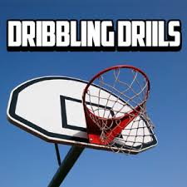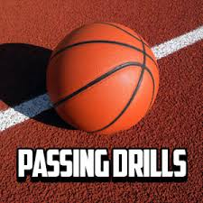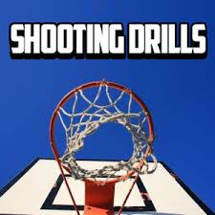

6 week sessions starting the week of November 3rd
Cost $65
1st Grade Boys – Tuesdays at 5:00
1st Grade Girls – Thursdays at 5:00
½ Day Kindergarten - Tuesdays at 12:30
Come join Coach Gina as she teaches the kids to shoot, dribble and pass a basketball. Kids will have a blast as they work through the drills and play fun games!
All kids will need to bring a basketball to class.

Sign up today at www.fit-rev.com – spots are limited

