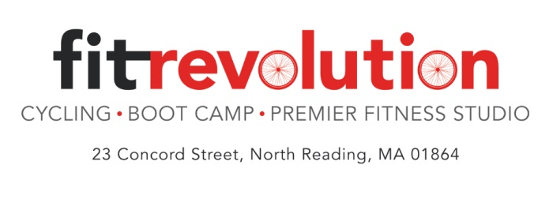
Group Rides with Wilston!
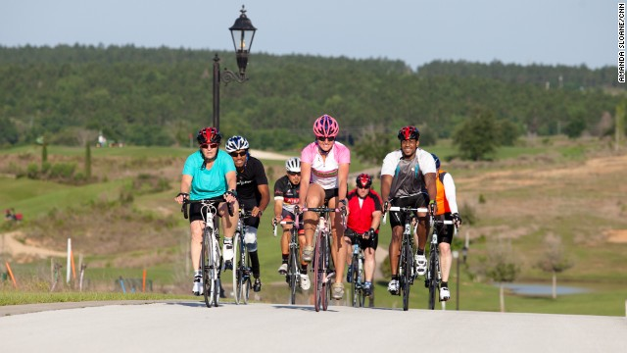

Looking for a group to ride with outside?
Join Wilston on Sunday mornings starting September 7th at 9:00am.
All levels welcome.
5 week session = $80
Sign up today, spots are limited!
Items you need: Bike Bag, Spare Tire, Tire changing kit, bike pump and a helmet.

To register sign up online at www.fit-rev.com.
Click on sign up for a class; go under EVENTS/Riding Group

