Running Group starting September 8th!

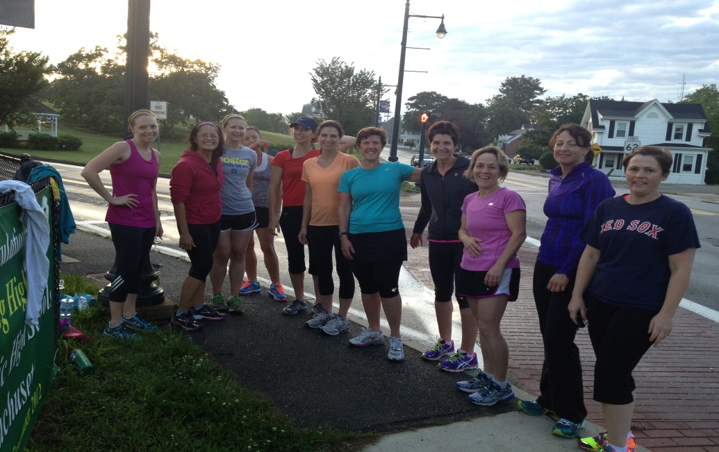

It’s time to set another goal here at Fit Revolution.
Time for us to put on our running shoes and MAKE THINGS HAPPEN!

This program is for EVERYONE!
All you need to tell us is if you are a beginner, intermediate or advanced runner.
We will guide you from there!

Join our group for 8 weekly training sessions.
Become a better runner and if you like,

Join us for the Cape Cod ½ Marathon on October 25th!

Speed/Interval Workouts
Mondays at 5:30am

Register today at www.fit-rev.com

Click on sign up for a class and go under EVENTS
Select Boston Strong Running

Cost $79 – 5 runners to run a group!

