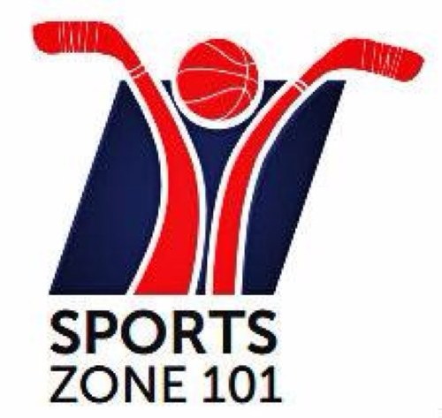

#### Sports Zone 101 at Fit Revolution

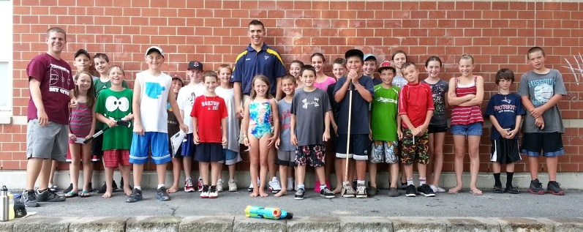

Please visit

Sports Zone 101 at

Fit Revolution

23 Concord Street

North Reading, MA

<http://www.Fit-Rev.com>

<http://www.sportszone101.com>

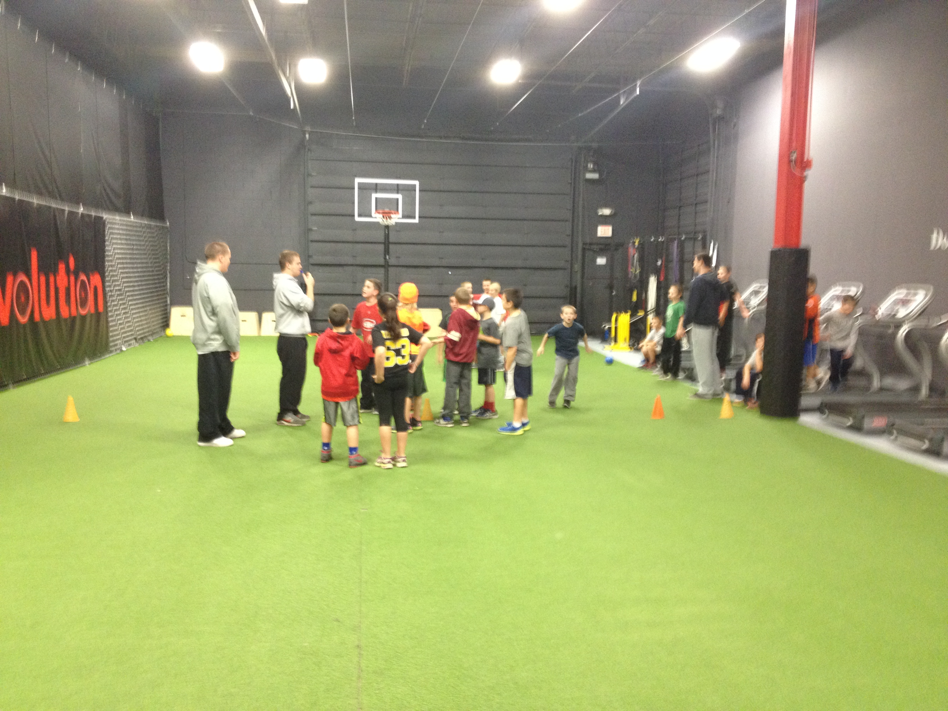

**Tournament of Champions:**

In this action packed class, children will participate in a variety of games, such as street hockey, soccer, football, dodgeball, basketball, basketball, and many others. Kids also learn the importance of good sportsmanship and being a great teammate!

Each participant will receive a daily sports prize.

Kids can **DROP-IN** to participate and play or sign up at Fit-Rev.com

CHECK FOR PROGRAM UPDATES AT SPORTSZONE101.com

**Sports Zone 101**

26 Glenmere Circle

Reading, MA 01867

Phone: 781-249-4797

For more information, please email at

[info@sportszone101.com](mailto:nface@sportszone101.com)

**© Active Education LLC**

**Sports Zone 101**

**All Rights Reserved**

# A Sports, Education, and Fitness Program for Kids

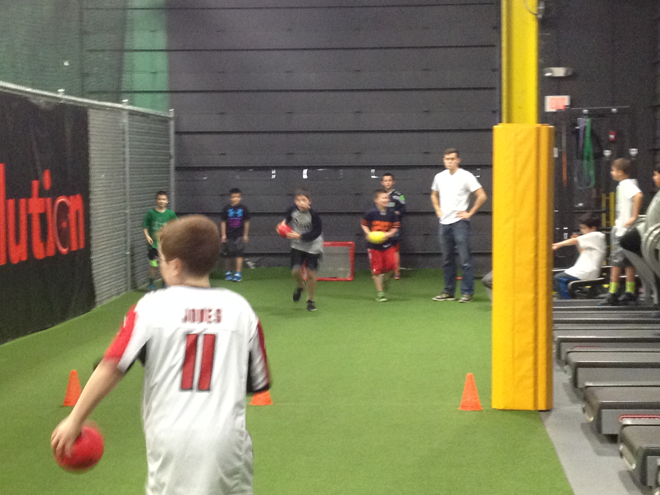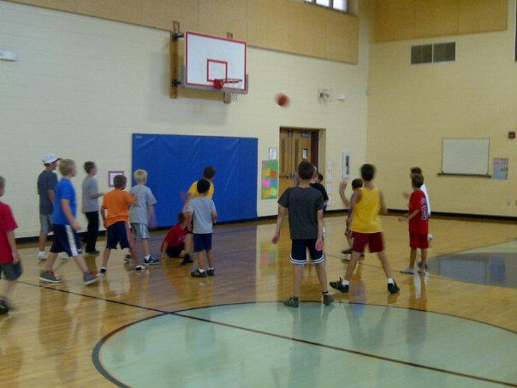

**“Where Champions are Made”**

# What does Sports Zone 101 do for kids?

* Improves communication and speech development for children
* Gives a child confidence and motivation
* Provides a fun way to exercise
* Supported by teachers within school systems
* Allows friendly competition and team building with games played.
* Creates a fun environment to make new friends

**© Active Education LLC**

**Sports Zone 101**

**All Rights Reserved**

We encourage kids of all ages to participate in all our programs. Open to boys and girls!

For more information about Sports Zone 101, please contact us at:

[info@sportszone101.com](mailto:info@sportszone101.com)

# Welcome to Sports Zone 101 at Fit Revolution

Welcome to the Sports Zone 101. Our main goal is to provide a safe, bully-free environment for children to improve their sports skills. During our classes children are engaged in a conversation pertaining to the weekly sporting events (scores, records broken, trades, and more). Kids also participate in games including basketball, football, baseball, soccer, dodgeball, street hockey, etc.

# History of Sports Zone 101

Northeastern graduates, Nick Face and Andrew Duval developed Sports Zone 101 in 2009. Nick was a former Reading High School graduate and avid fan of sports. Andrew has been an avid sportsman, participating in Rugby, Basketball, Baseball and Rowing.

# What does a Sports Zone 101 class entail at Fit Rev?

# Each program begins with a recap of what’s happening in the professional sports world. After our brief discussion, we play a variety of games including: dodgeball, street hockey, basketball, whiffleball, football, basketball, etc. At the conclusion of each class, all participants select a pack of sports cards to take home.

# 

# 

# Birthday Parties at

# Sports Zone 101:

At our parties, we supply all the sports prizes, equipment, goodie bags, staff, and space to play all our games. Your child is able to choose any game they want to play. At the end of the party, your child receives a jersey card as a birthday gift from Sports Zone 101.

We ask for 1-2 week notice for scheduling parties. To request pricing for a birthday party, please contact:

Birthdays@sportszone101.com