FIT REVOLUTION INTRODUCES
CARDIO SPORT coming this Fall…
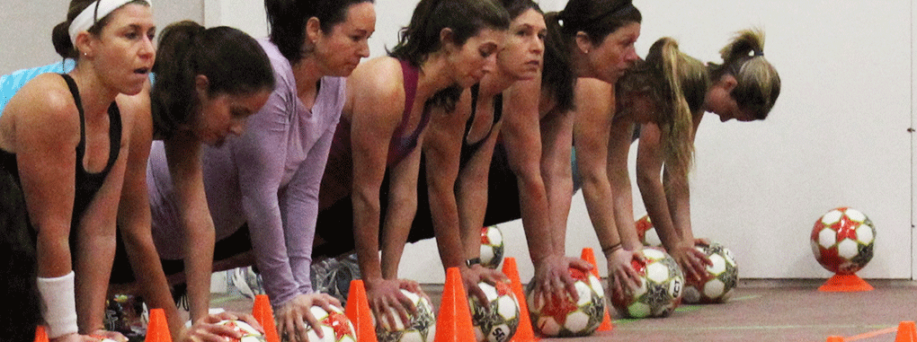
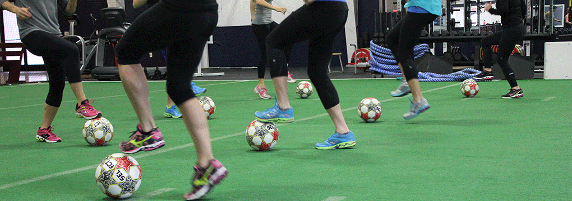

Cardio Sport is the creator, and leader of comprehensive athletic conditioning integration in a group exercise environment.
Cardio Sport is a comprehensive group fitness adventure that uniquely integrates interval training techniques with compound sports-related movements in an unparalleled inspiring exercise environment. It is the most comprehensive conditioning system in the market today. What separates Cardio Sport from any other fitness product is its unique ability to provide a targeted wellness plan that compliments any fitness enthusiast. Whether you are just beginning your fitness journey or a seasoned athlete, only Cardio Sport delivers an exercise experience that will elevate every participant’s overall health and fitness, and provide a motivational atmosphere that drives you to consistency.
Our system works on two platforms of group classes: CS-GROUP DYNAMIC and CS-GROUP STRENGTH TRAINING.
Classes coming this Fall – Sign up for our FREE DEMO – September 17th at 9:30am!

